Querying and Visualizing Protests through Neo4j’s Temporal Knowledge Graphs

Hexin Liu  
*University of North Carolina in Greensboro*Greensboro, USA  
H_LIU4@uncg.edu

Chunjiang Zhu

*University of North Carolina in Greensboro*

Greensboro, USA

H_LIU4@uncg.edu

*Abstract*— Temporal knowledge graphs are one of the main subjects in research due to their abilities to detail events and the dates of which these events occur [2] [3] [4] [5] [6]. These graphs are useful in studying how historical events occur within a certain timespan [2] [3] [4] [5] [6]. This paper will delve into the implementation process of Neo4j to study how to use temporal knowledge graphs to observe the characteristics of protests [2] [3] [4] [5] [6]. Furthermore, the paper will describe the results and conclude with a discussion about the next tasks to take to further our study on protest behaviors [2] [3] [4] [5] [6].

Keywords—protests, temporal knowledge graphs, historical and current events

# Introduction

There has been interest in using temporal knowledge graphs to structure information concerning social interactions and their occurrences [2] [3] [4] [5] [6]. To show information about the current or historical events [2] [3] [4] [5] [6], the temporal knowledge graphs use nodes to denote entities [2] [3] [4] [5] [6] and edges to denote actions [2] [3] [4] [5] [6] and the date of which the actions happen [2] [3] [4] [5] [6]. Because temporal knowledge graphs include temporal information (unlike their vanilla knowledge graph counterparts) [2] [3] [4] [5] [6], the temporal knowledge graphs are ideal in studying how one event transitions to another [2] [3] [4] [5] [6] and how one entity interacts with another one in a specific timespan [2] [3] [4] [5] [6]. As such, research has been done to apply temporal knowledge graphs in areas specialized in knowledge reasoning, entity alignment, and other tasks [2] [3] [4] [5] [6]. Seeing the potential of temporal knowledge graphs to document events [2] [3] [4] [5] [6] and be functional for the querying process of finding political rally activities [2] [3] [4] [5] [6], we decided to use the graphs to visualize protests to see how impactful they are [2] [3] [4] [5] [6]. Hence, the TKGs can help to query and visualize the protest activities potential for future research in the social sciences concerning political resistance [2] [3] [4] [5] [6].

# Research Methodology

## Tools and other Materials

We used the Neo4j software application to construct the graph based on the information from the loaded dataset and observe the output of our input queries on our created graphs. The query language that we have used in Neo4j is Cypher. We also employed the 2017 Integrated Crisis Early Warning System (ICEWS) dataset as a dataset more suited for the topic of protest activities [1]. We then later on used the Google Colab system to create the protest/non-protest labelling for the ICEWS dataset using Python libraries, such as openpyxl and Gensim.

## Current Progress

We first started to extract the first 100 rows from the 2017 ICEWS dataset and created our knowledge graph based on the first 100 rows. We implemented the source/target names, countries, and sectors from the dataset as properties for each entity nodes. We additionally determined the properties of the relations to be the event texts, event dates, the publishers’ names, and the publisher id. After experimenting with the 100-row file, we then tackled in loading the 1,000-row file and forming the graph. We then created queries to observe any interesting insights about the graph, including the current events that the Xinhua News Agency has noted and which entities have made statements. We then transitioned into testing the 3,000-row file. During this process, we created the graph out of the 3,000-row file and made queries having keywords related to protests. For example, we typed a query that includes the word “rally” to observe the graphs that delve into rallying actions.

After trying with the reduced-row versions of the dataset, we then moved on to upload all of the dataset into the remote Neo4j server through SSH porting and managed to upload all of the rows into the server. Then, we transitioned to creating the labelling system in the Google Colab due to the fact that the labelling can reveal the essential reference for the human labelers. Most importantly, it can also assist in querying events pertaining to protests and reveal interesting observations of the interactions between entities. We decided to use Google Colab for automatic labelling as the drawback for doing protest/non-protest labelling in Excel is that this labelling will ignore rows that hint at the idea of protests yet do not mention protests directly. In light of this flaw, we resorted in using the word embedding method where we created a list of similar words based on the given word with Gensim’s (a library from Python) most_similar method. This list will then act like a mechanism for analyzing the similarity between the word in each dataset’s row and each word from the list. Each event from the dataset is determined by whether the computed similarity is more or equal to the threshold value. If the value is larger, it is classified as a protest; if not, it is considered as non-protest.

# Results

We have devised 10 queries regarding protest activities with all the rows being loaded to the Neo4j server. We decided to use the ‘limit 10’ command to avoid complications in displaying the graphs. Below are screenshots of the queries and the outputs that they produced, the query statements for the outputs, and a brief description of the screenshots to explain how the queries functioned.

Activist Query

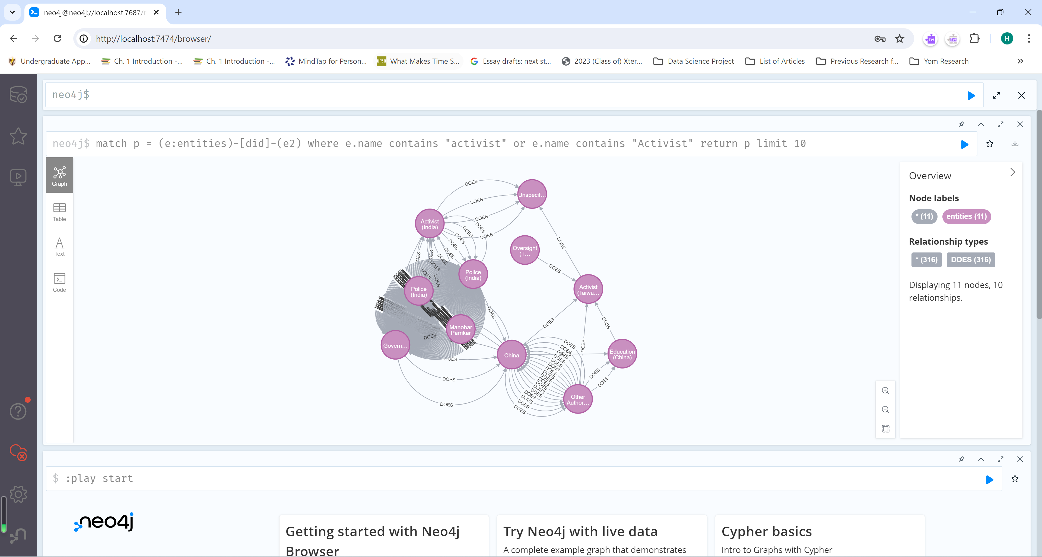

Fig. 1. The Activist Query and the Resulting Graph

The activist query uses the following sentence: ‘match p = (e:entities)-[did]-(e2) where e.name contains "activist" or e.name contains "Activist" return p limit 10.’ The activist query returns graphs that have nodes containing names that correspond to the word ‘activist.’ The activist query consists of 11 nodes and 10 relations, considering the use of the ‘limit 10’ command.

“Another Protestor” Query

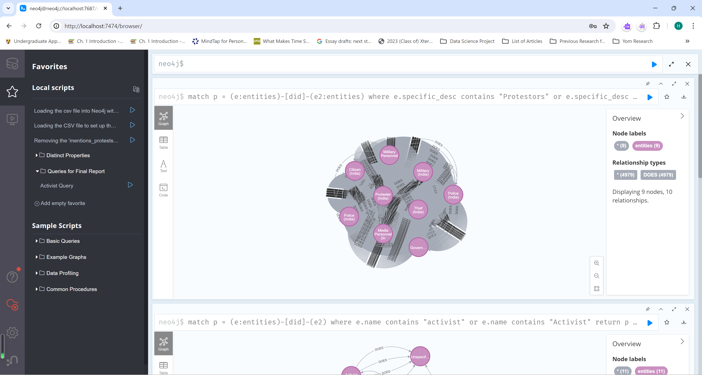

Fig. 2. The “Another Protestor” Query and the Resulting Graph

The statement for the ‘another protestor’ query is ‘match p = (e:entities)-[did]-(e2:entities) where e.specific_desc contains "Protestors" or e.specific_desc contains "protestors" return p limit 10.’ The “another protestor” query employs the specific description (specific_desc) of a node to find patterns in the graph related to protests. The protestor query returns 9 nodes and 10 relations.

Demonstrate Query

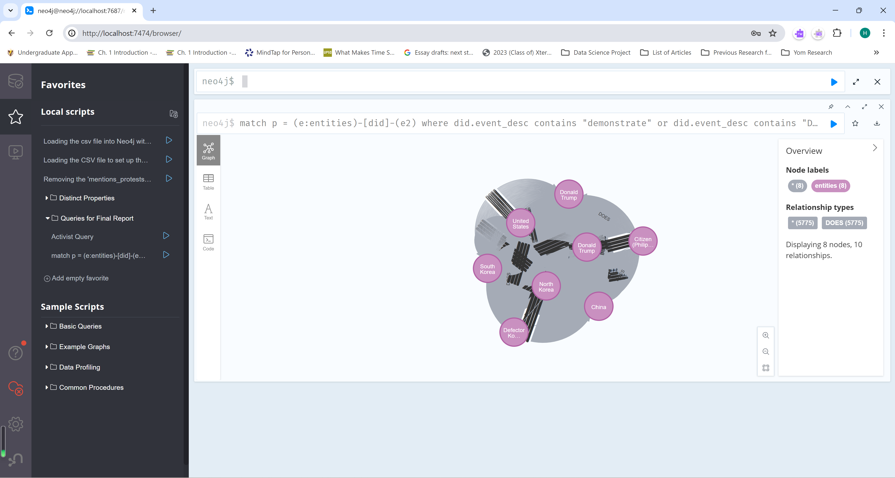

Fig. 3. The Demonstrate Query and the Resulting Graph

In the demonstrate query, the clause implemented for the demonstrate query is ‘match p = (e:entities)-[did]-(e2) where did.event_desc contains "demonstrate" or did.event_desc contains "Demonstrate" return p limit 10.’ The demonstrate query presents graphs with the relations’ (“did”) event descriptions matching to the term “demonstrate,” as in political marches. The graph produced by the demonstrate query has 8 nodes and 10 relations.

Opposition Query

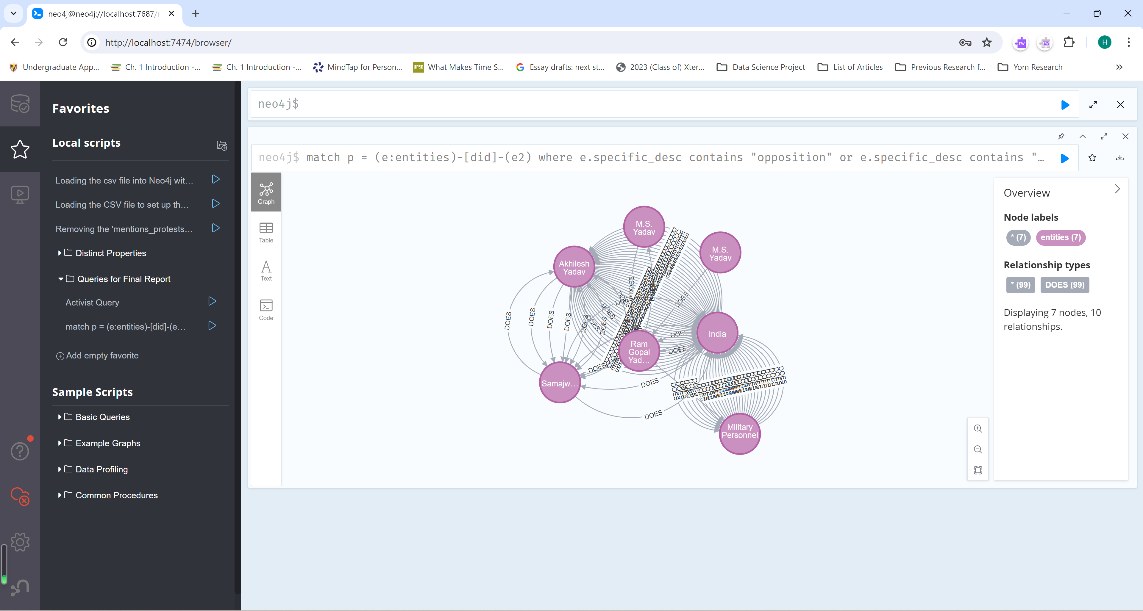

Fig. 4. The Opposition Query and the Resulting Graph

The opposition query consists of this phrase: ‘match p = (e:entities)-[did]-(e2) where e.specific_desc contains "opposition" or e.specific_desc contains "Opposition" return p limit 10.’ The opposition query returns a graph with nodes’ including the word ‘opposition’ in their specific descriptions. The resulting graph consists of 7 nodes and 10 relations.

Protest Query

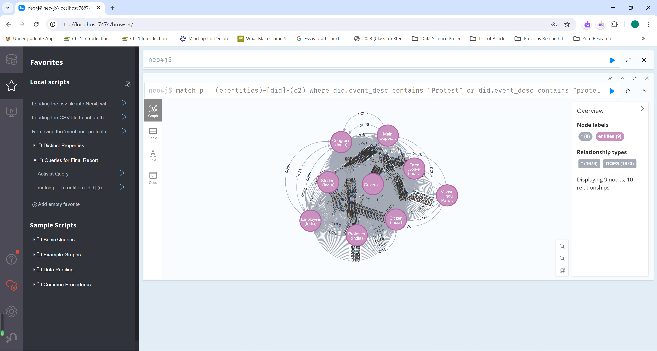

Fig. 5. The Protest Query and the Resulting Graph

The protest query includes the clause ‘match p = (e:entities)-[did]-(e2) where did.event_desc contains "Protest" or did.event_desc contains "protest" return p limit 10.’ The protest query takes patterns where the relations match to the term “protest.” The returned graph contains 9 nodes and 1,673 relationships.

Protestor Query

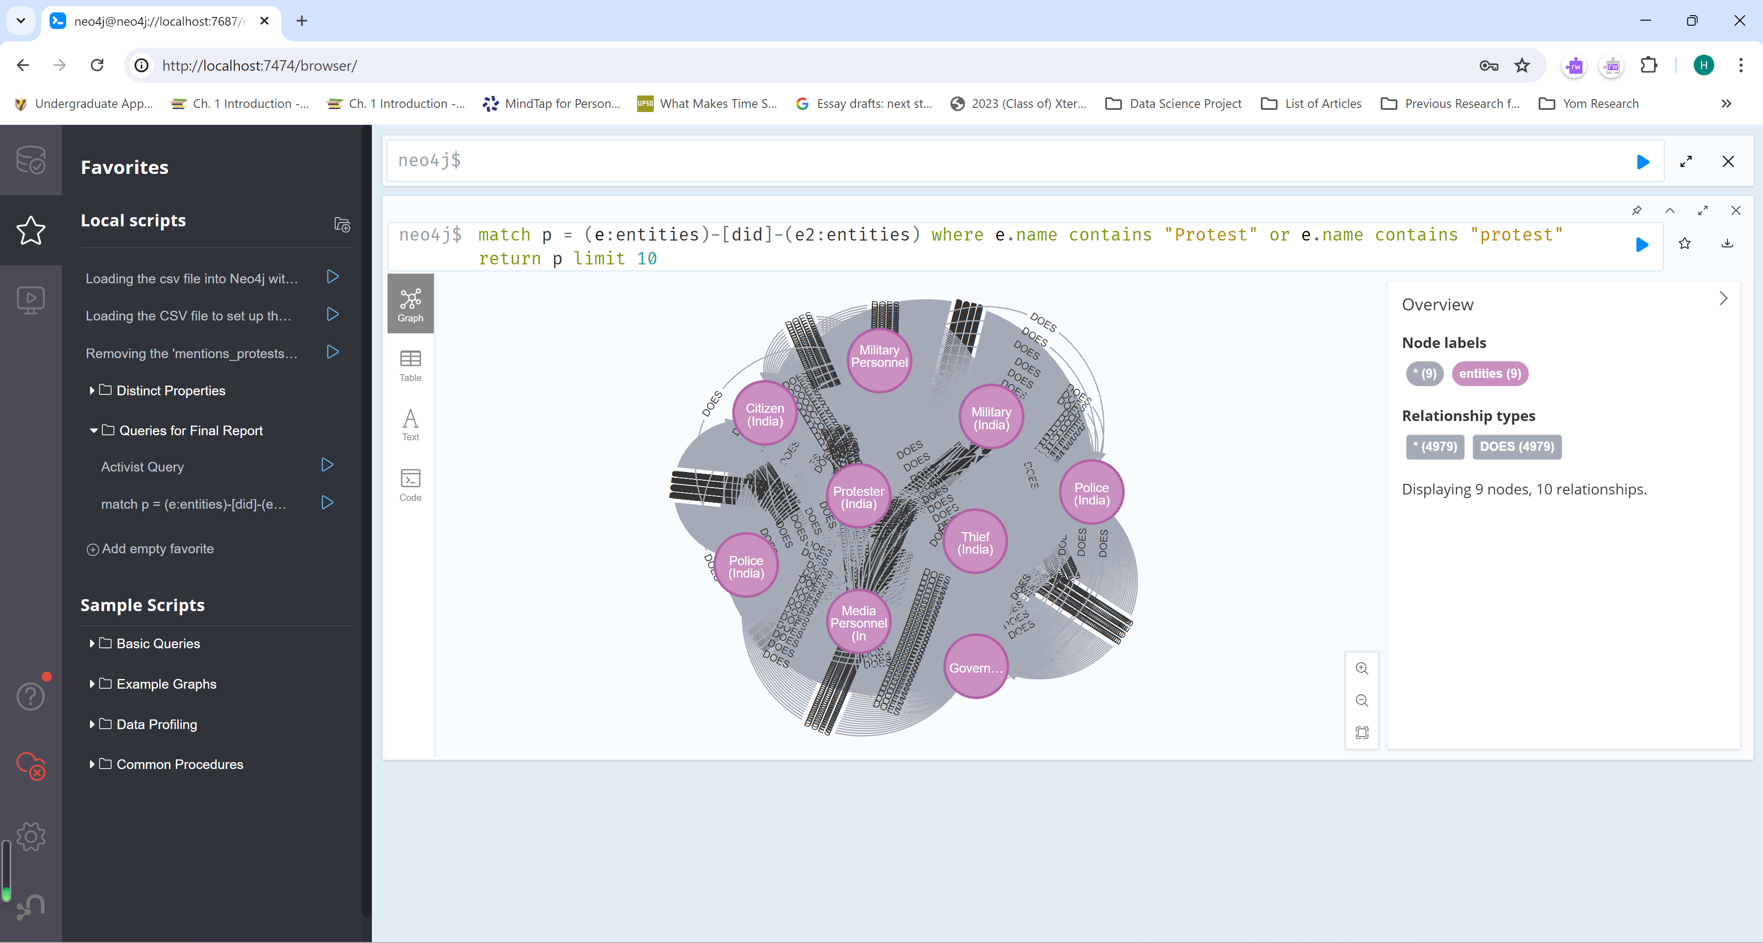

Fig. 6. The Protestor Query and the Resulting Graph

The Cypher structure of the protestor clause is ‘match p = (e:entities)-[did]-(e2:entities) where e.name contains "Protest" or e.name contains "protest" return p limit 10.’ Like the protest query, the protestor query selects nodes that involve protestors (in this case, the noun form of “protest”) and returns the patterns relating to these nodes. The graph of the protestor query encompasses the 9 nodes and 10 relationships.

Rally Query

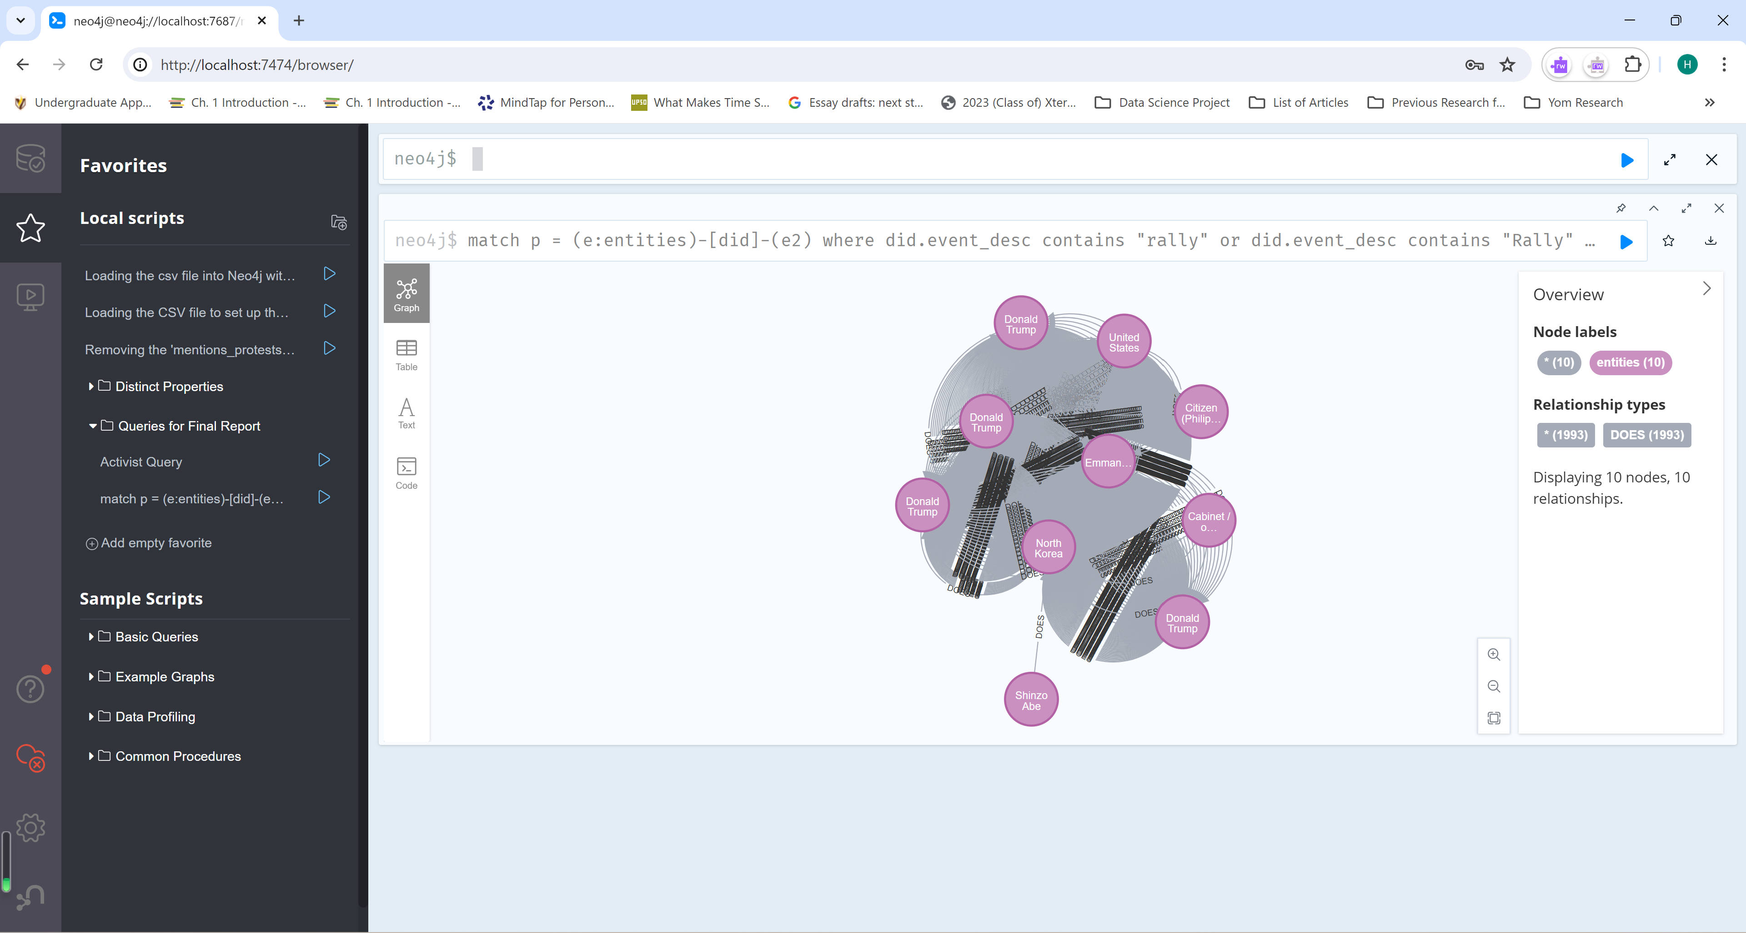

Fig. 7. The Rally Query and the Resulting Graph

The clause in the rally query is made with this command: ‘match p = (e:entities)-[did]-(e2) where did.event_desc contains "rally" or did.event_desc contains "Rally" return p limit 10’ The rally query returns graphs pertaining to the action of rallying. The returned graphs contain 10 nodes and 10 relationships.

Riot Query

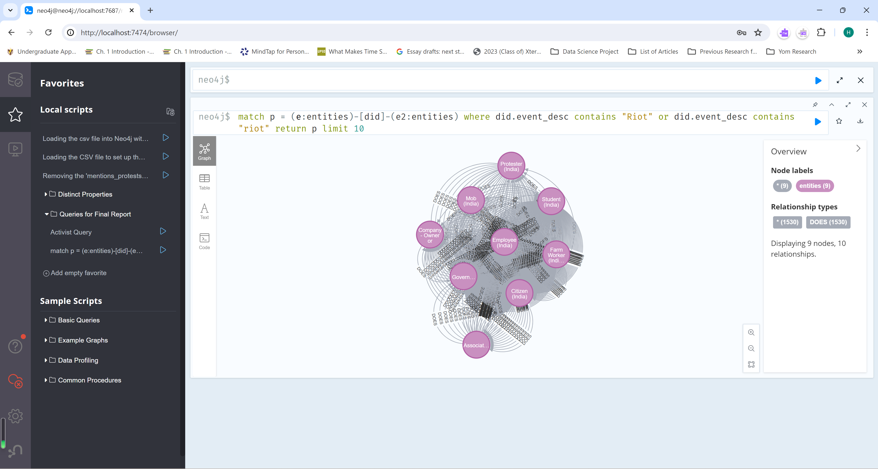

Fig. 8. The Riot Query and the Resulting Graph

The statement utilized to build the riot query is ‘match p = (e:Entities)-[did]-(e2:Entities) where did.event_desc contains "Riot" or did.event_desc contains "riot" return p limit 10.’ The riot query will select graphs that involve relations parallel to rioting. The riot query’s graph comprises of 9 nodes and 10 relationships.

Rioter Query

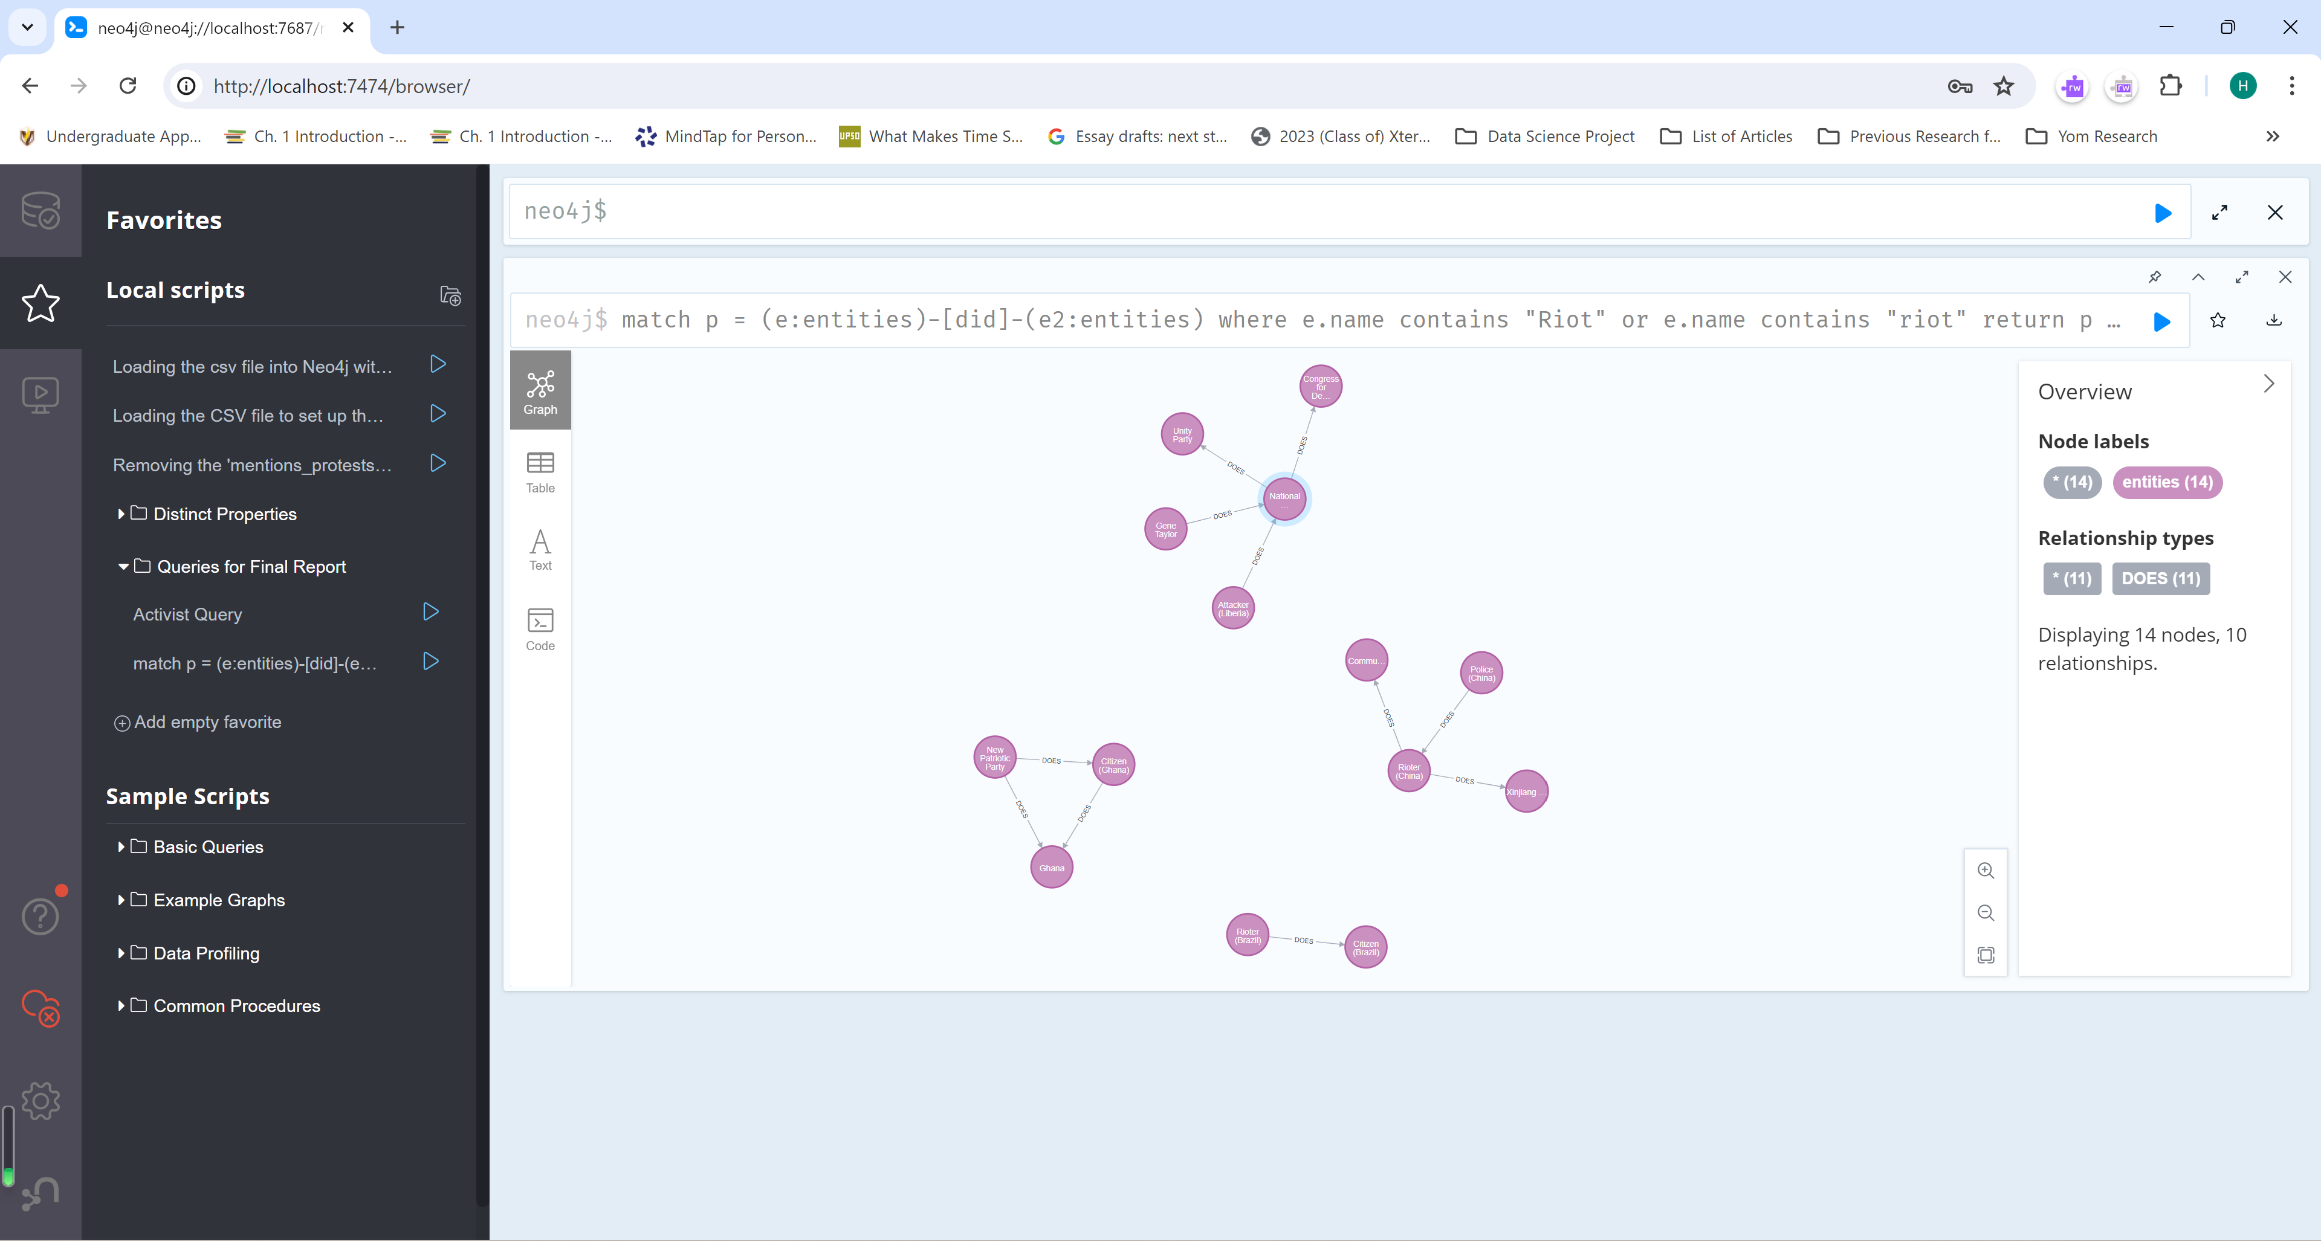

Fig. 9. The Rioter Query and the Resulting Graph

The rioter query contains the clause ‘match p = (e:entities)-[did]-(e2:entities) where e.name contains "Riot" or e.name contains "riot" return p limit 10.’ The rioter query is similar to the riot query but focuses more on finding the nodes referring to rioters and their corresponding edges. The generated graph uses 14 nodes and 10 relationships.

Strike Query

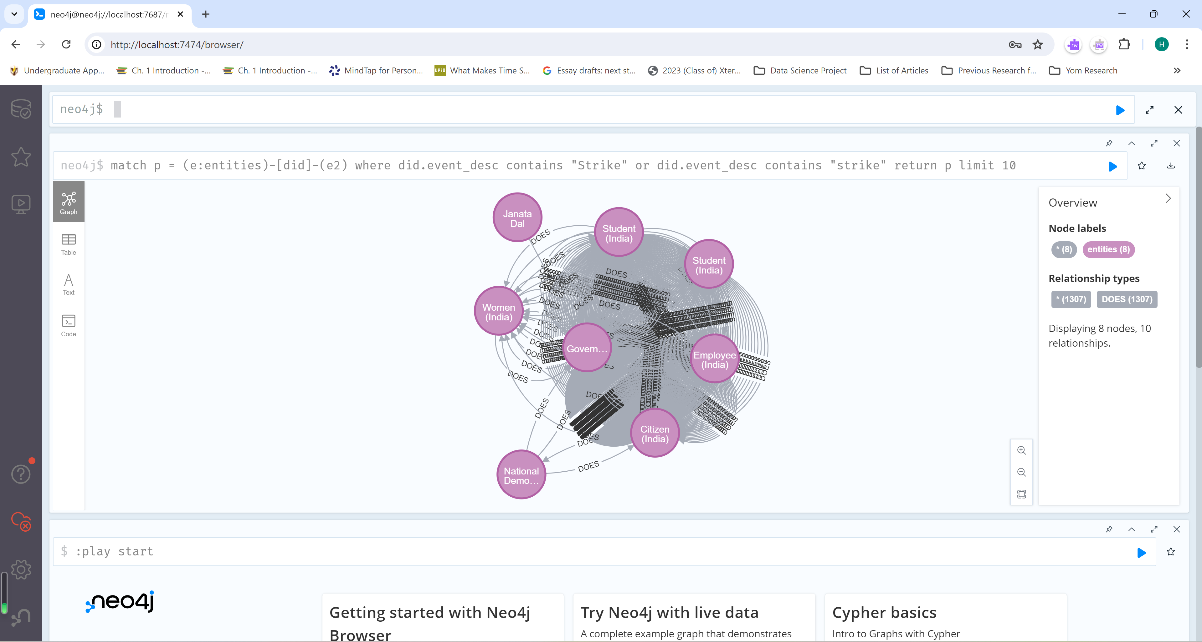

Fig. 10. The Strike Query and the Resulting Graph

The structure of the clause for the strike query is ‘match p = (e:entities)-[did]-(e2) where did.event_desc contains "Strike" or did.event_desc contains "strike" return p limit 10’ The strike query outputs a graph that involves a strike—a form of political action. The graph presented by the strike query consists of 8 nodes and 10 relationships.

# Further Steps

We would like to complete employing the protest/non-protest labelling to the CSV version of the dataset. To do so, we would attempt to use the GLOVE model from the Gensim Python library to collect the first 50 similar words of our given word. We would then use the lemmatizer from the NLTK library to retrieve a list with no words with similar root word. We would also employ the openpyxl module to go through each relevant row’s values to calculate the similarity between each row’s word and the word from the list. We will then use the similarity value to see if the event should be categorized as a protest or non-protest instance. We are also open on utilizing the t-nse for visualizing the protest events with the non-protest ones. We also would like to produce the similarity score for each event in the dataset and the bag-of-words concerning protests.

##### Acknowledgment

We would like to acknowledge Dr. Chunjiang Zhu for offering resources about knowledge graphs, providing advice on building the graph and future implementations, and suggesting on using the Neo4j graphs to learn about the protests.

##### References

1. Elizabeth Boschee; Jennifer Lautenschlager; Sean O'Brien; Steve Shellman; James Starz; Michael Ward, 2015, "ICEWS Coded Event Data", <https://doi.org/10.7910/DVN/28075>, Harvard Dataverse, V37, 2015, Events.2017.20201119.zip
2. Jiabin Tang, Yuhao Yang, Wei Wei, Lei Shi, Lixin Su, Suqi Cheng, Dawei Yin, Chao Huang, “GraphGPT: Graph Instruction Tuning for Large Language Models,” arXiv, May 2024.
3. Li Cai, Xin Mao, Yuhao Zhou, Zhaoguang Long, Changxu Wu, Man Lan, “A Survey on Temporal Knowledge Graph: Representation Learning and Applications,” arXiv, March 2024.
4. Mod*U: Powerful Concepts in Social Science, “What is Social Network Analysis?” YouTube, Aug 2015.
5. Wenqi Fan, Shijie Wang, Jiani Huang, Zhikai Chen, Yu Song, Wenzhuo Tang, Haitao Mao, Hui Liu, Xiaorui Liu, Dawei Yin, Qing Li, “Graph Machine Learning in the Era of Large Language Models (LLMs),” arXiv, 2023.
6. Yao Ma, Jilang Tang, “Deep Learning on Graphs,” 2020.